**Organization Structure**

**Departments (Sub-Unit)**

1. Design
2. Manufacturing
3. Building
4. Testing
5. Sales
6. Maintenance
7. Financial

**Locations**

1. America
2. Europe
3. Africa
4. Asia - Pacific

**Users**

1. Head
2. Employee(s)

**Policies**

1. Password Policies
   1. Min. characters 6
   2. Special characters must
   3. At Least 1 small and 1 capital letter
   4. No name and email required
2. Personal Information Collection

**Identity Data**, which may include your first name, last name, and title.

**Contact Data**, which may include your postal address, email address, and telephone numbers.

**Financial Data**, which may include your payment card details and billing address.

**Profile Data**, which may include username and password, purchases made by you, and customer service requests.

**Technical Data**, which includes your internet protocol (IP) address, browser type and version, time zone setting and location, browser plug-in types and versions, and operating system and platform.

**Usage Data**, which includes information about how you use our website.

**Marketing and Communications Data**, which includes your preferences in receiving marketing and non-marketing communications from us.

**Employment Data** – if you apply for employment with SpaceX, we will collect your employment and work history, as well as personal information related to your potential employment. This may include your education and employment history, address and contact information, demographic information, and any other information included in your resume or application.

Site Map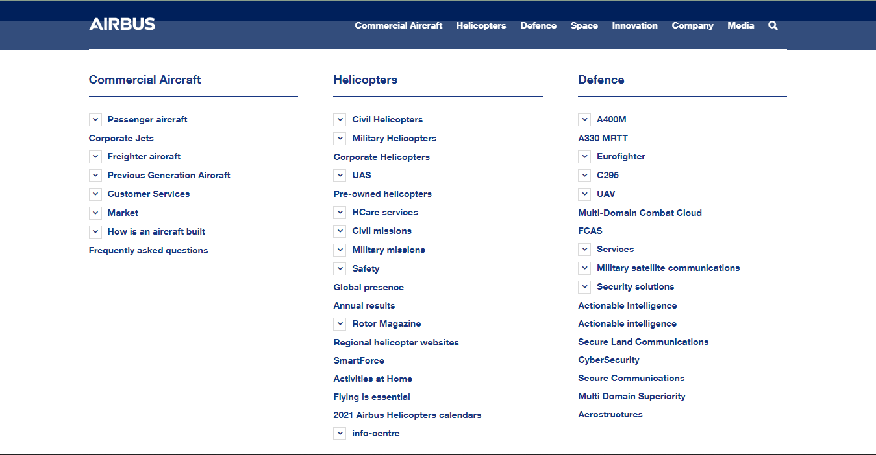

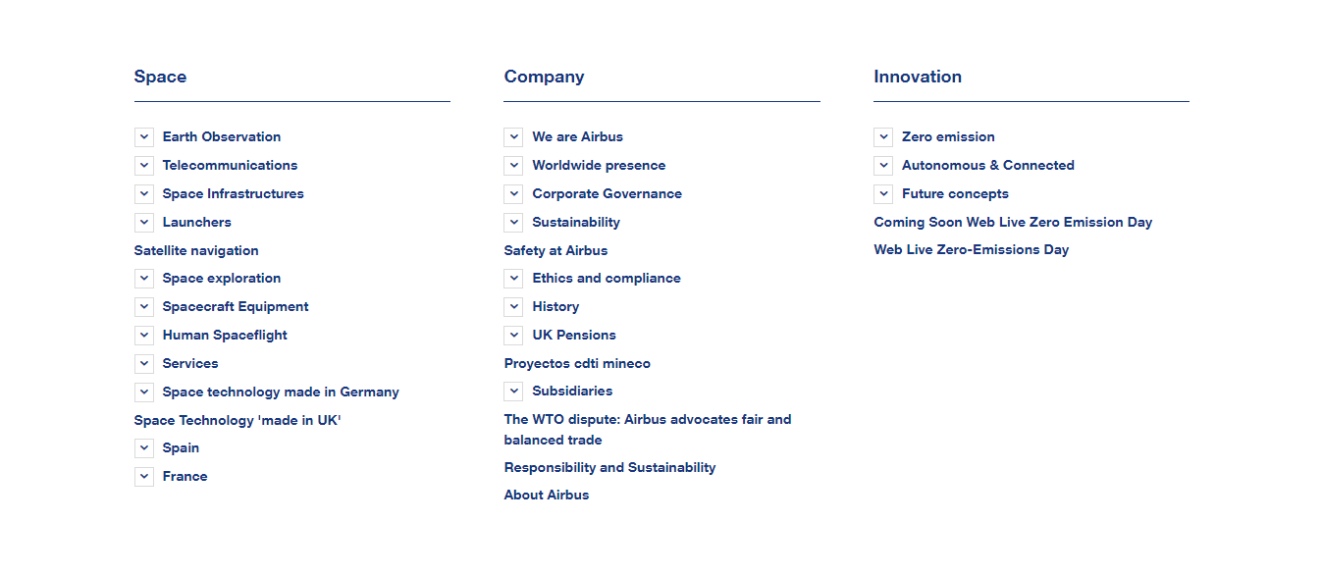

Tools used

**->** **ISIM (System no. 104) (Anydesk ID - 165170253)**

**->** [**Online CSV generator**](https://extendsclass.com/csv-generator.html)

**Task to be performed**

**->CSV Identity Feed Service - for all sub-units**

**->Identity Policy**

**->Password Policy**

**->Titles - Commercial, Helicopter, Space**